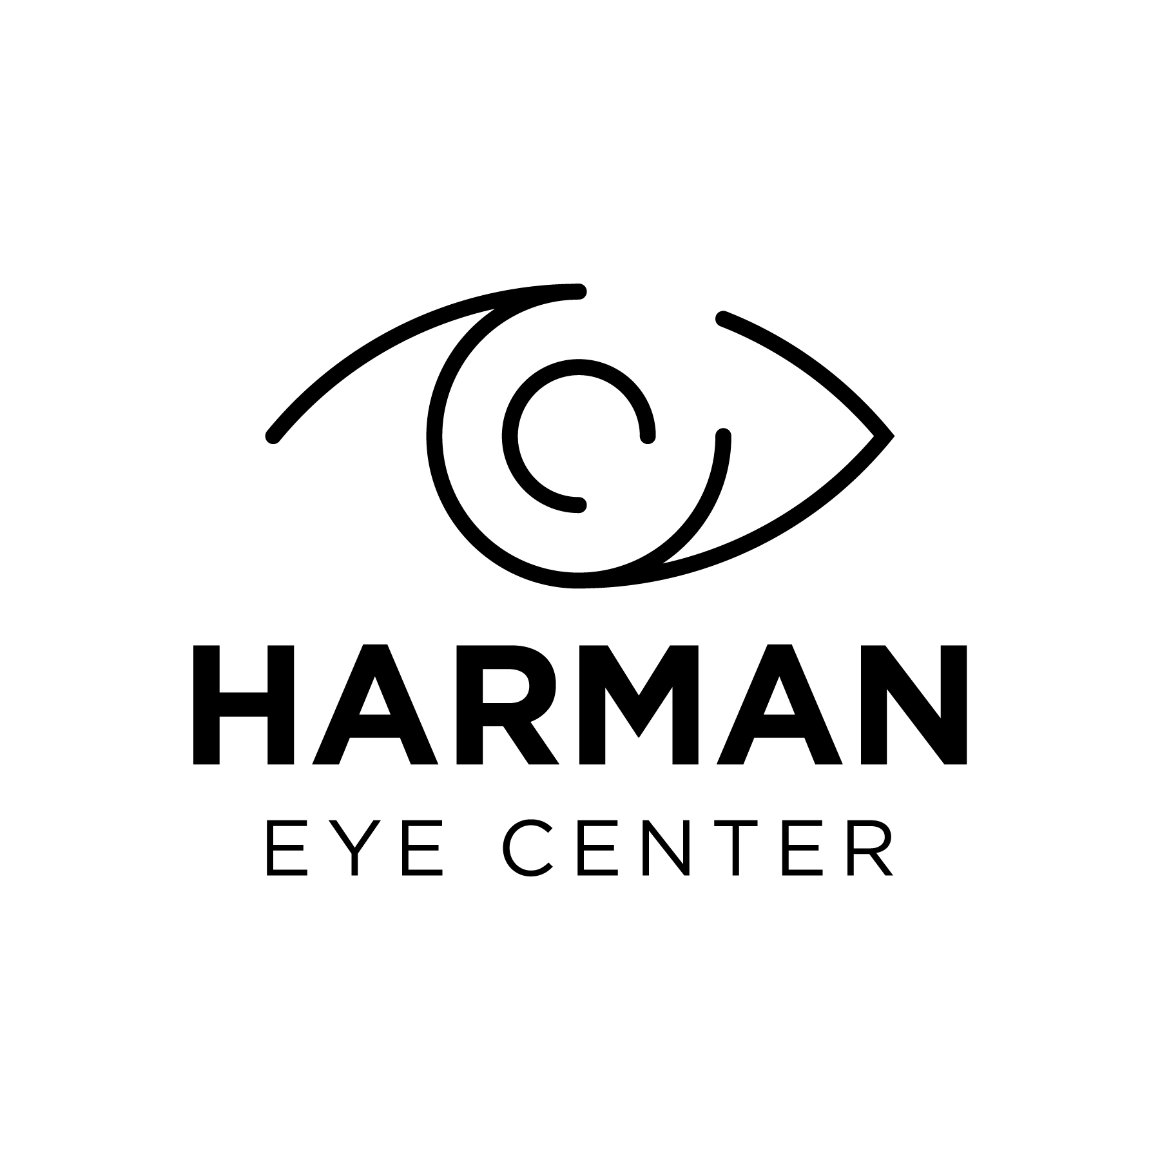 | Harman Eye Center  Harman Eye Center of Amherst  Harman Eye Center of Appomattox  Harman Eye Center of Danville  Harman Eye Center of Lovingston  Harman Eye Center of Lynchburg  Harman Eye Center at Wyndhurst  Surgery Center of Central Virginia
P.O. Box 1290 | Forest, VA 24551
Phone: 434-385-5600 | Fax: 434-616-2313 | | www.Harmaneye.com

AUTHORIZATION TO RELEASE HEALTHCARE INFORMATION
Patient’s Name: ________________________________________ | Date of Birth___________________________
Previous Name: ________________________________________ | Social Security #: _______-______-_______
I request and authorize _____________________________________ to release healthcare information of the patient named above to: | Harman Eye Center  P.O. Box 1290  Forest, VA 24551
 | Fax: 434-616-2313
This request and authorization applies to:
[List here]
[List here]
[Additional information]
[List here]
I understand that I have the right to access my medical records in accordance with the law and the policies of Harman Eye Center. I may revoke this consent at any time except to the extent that action has already been taken on it and that it will expire automatically ninety (90) days from the date indicated below. Please note that information disclosed pursuant to this request is no longer under the control of Harman Eye Center and may be subject to re-disclosure by the recipient and may no longer be protected by federal or state law.
Patient Signature: |  | Date signed: [Date]
Witness Signature: |  | Date signed: [Date]
Patient’s Legal Representative: |  | Date signed: [Date]

